Heart Stroke Prediction using Machine Learning

Abstract
One of the most important tasks in the world today is the prediction of heart disease. Several folks have recently passed away from heart illness. In training and testing the vast amounts of data used in the medical industry, machine learning is crucial. The challenge of developing and evaluating a heart disease prediction system is essential to preventing the disease and warning the patient before symptoms appear. By utilizing various machine learning approaches, such as Decision Tree and Logistic Regression, this study predicts the likelihood of heart disease and determines if the patient has heart disease or not. Eventually, this research demonstrates a heart disease outcome, and comparative trials have demonstrated that the patient's forecast may be given using the suggested method.
Keywords: Keywords: Heart Stroke, Classification Algorithms, Machine Learning, Kaggle dataset.
Introduction
The research that is suggested in this model mostly focuses on different techniques used to predict cardiac disease. The heart plays a major role in the human body and controls the flow of blood throughout the entire body. Fundamentally, the body suffers greatly if the heart is unable to regulate blood properly. Any false information may impact your risk of developing heart disease and having a heart attack. Heart disease is one of the main causes of common fatalities in this generation in the current period because of their luxurious and unhealthy lifestyles, which include excessive alcohol use, fast food consumption, smoking, and stress.
According to the World Health Organization, thousands of individuals die each year because of this cardiac condition. A healthy lifestyle can protect you from heart disease earlier. The primary means of saving lives is to develop better prediction systems and assist the underprivileged. Due to modern-day affluence and improper food, heart illnesses are discovered to be the leading cause of death worldwide. To prevent significant losses, the planned work aims to assess heart problems at an early stage. Machine learning algorithms and approaches can be used to forecast different cardiac illnesses in the medical field.
How machine learning is playing a role in analyzing the symptoms of heart diseases.
Machine learning is being used to develop predictive models that can identify individuals at high risk of developing heart disease based on their symptoms and other risk factors. Decision support systems analyze patient data to generate personalized risk assessments and provide recommendations for treatment and preventive measures. Machine learning algorithms are also used to analyze medical images and large datasets of patient information to identify early signs of heart disease and patterns and risk factors associated with the condition. Overall, machine learning is playing a crucial role in analyzing heart disease symptoms and helping doctors make more accurate diagnoses and develop effective treatment plans.
Machine learning algorithms being used by research in medical field.
Machine learning algorithms are widely used in the medical field for analyzing complex data sets and developing effective diagnostic and treatment methods. These algorithms help to accurately diagnose various diseases, predict patient response to different treatments, identify new drug targets, and analyze medical images to detect signs of disease. In summary, machine learning algorithms are crucial in advancing medical research and improving patient outcomes.
Various heart diseases
Heart disease is a broad term that encompasses several different types of conditions affecting the heart, including coronary artery disease, heart failure, arrhythmia, valve disease, cardiomyopathy, congenital heart disease, and aortic aneurysm. Symptoms and treatments for each type of heart disease vary depending on the specific condition, but may include medications, lifestyle changes, surgery, or other procedures. Effective management and risk reduction require working closely with a healthcare provider.
Signs and Symptoms of heart stroke
The signs and symptoms of a heart stroke can vary but may include chest pain or discomfort, shortness of breath, sweating, nausea or vomiting, light-headedness or dizziness, fatigue, and irregular heartbeat. Some people, particularly women, may experience less typical symptoms. It's important to seek emergency medical attention immediately if you experience any of these symptoms, as early treatment can save lives and limit damage to the heart muscle.
Treatment of Heart Stroke
A heart stroke, also called a heart attack or myocardial infarction, is a medical emergency that requires immediate treatment. Treatment aims to restore blood flow to the heart muscle and prevent further damage. Common treatments include medications to dissolve blood clots, angioplasty to open blocked arteries, coronary artery bypass surgery to create a bypass around the blocked artery, lifestyle changes like quitting smoking and eating a healthy diet, and cardiac rehabilitation. The treatment may vary depending on the severity of the condition and individual patient needs. If you suspect a heart stroke, call emergency medical services immediately.
Importance of AI and Machine learning in recognizing heart stroke beforehand.
AI and machine learning can analyze large amounts of patient data and identify patterns and risk factors associated with heart stroke, allowing for the development of predictive models to identify patients at high risk. Wearable devices can also be used to monitor patients in real-time and identify early warning signs. The use of AI and machine learning has the potential to improve patient outcomes and reduce healthcare costs, but further validation and testing is needed before widespread implementation in clinical practice.
Comparative analysis of related work in the form of table
Author (Year) | Techniques | Datasets | Remarks
Wang, J., & Xu, J. (2019) | KNN | Kaggle | Average
Prasad, P., & Thakur, R. (2020) | Random Forest | Random | Best
Khan, A., & Mustafa, S. (2021) | Decision Tree | Kaggle | Good

Table 1
Literature Review
An artificial neural network-based model for "Predicting the Risk of Heart Disease Using HER (Electronic Health Record) was presented by Bo Jin and Chao Che in 2018. To conduct the study and make the heart disease predictions in this paper, real-world datasets from patients' electronic health records were employed. In order to integrate the fundamental concepts of an enlarged memory in the neural network model, we developed a one-hot encryption model that detects events and heart risk failure events victimization. By examining the findings, we hypothesized that it would become clear how crucial it is to respect the outcomes of nature in records.
Fahd Saleh created and presented a machine learning model that compares five different types of algorithms. In contrast to Matlab software and Weka tools for data mining, a Rapid Miner tool produced higher accuracy. The classification techniques Decision Tree, Logistic Regression, Random Forest, Naive Bayes, and SVM were employed in this study. The most accurate algorithm is the decision tree algorithm.
A system that employs NB (Naive Bayesian) approaches for dataset categorization and the AES (Advanced Encryption Standard) algorithm for safe data transport was proposed by Anjan Nikhil Repaka, et al.
Fast rule based cardiac disease prediction with associative approach was a model developed and implemented by K.Prasanna Lakshmi and Dr. C.R.K. Reddy in 2015. The author used chi-square test to predict the disease using certain associative techniques from the model.
Pure Classifier Association Rule is the model that M. Satish, et al. developed and used to predict the heart disease model using naive bayes and decision tree models. For this approach, he employed a data warehouse dataset on heart illness.
"Heart Disease Prediction via Evolutionary Rule Learning" was first published by Aakash Chauhan (2018). This study lessens the human work required to directly extract information (data) from electronic records. We must use some frequency of pattern growth along with data mining on the patient dataset to extract this kind of rule. The majority of the rules help with the best heart disease prognosis, and this will analyse and strive to lower the cost of services.
In this project, a review of the literature reveals how machine learning approaches have been investigated for heart disease from the studies mentioned above. By utilizing some machine learning methods, it is possible to analyse the prediction model with the greatest accuracy possible.
The primary goal of this project/paper is to forecast the patient's risk of developing heart disease or a heart attack using machine learning methods like logistic regression to find the prediction as a series of 0s and 1s. The user of this project can learn more about the output from these 14 different types of input attributes. 14 attributes will then be tested and trained on the data to produce reliable and effective disease prediction results.
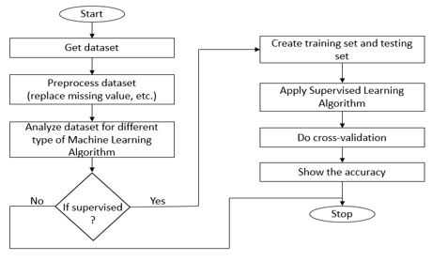

Fig: 1 Flow Chart

Proposed Model
The suggested study examines the four classification algorithms stated above and performs performance analysis to predict heart disease. This study's goal is to accurately determine whether a patient has heart disease. The healthcare provider inputs the data from the patient's health report. A model that predicts the likelihood of having heart disease is fed the data.

Table: 2
Data Gathering and Preparation Just the UCI Cleveland dataset, which is a mix of 4 separate databases, was used for the Heart Disease Dataset. Although this database has 900 total properties, all published experiments only mention employing a subset of 14 aspects. We used the UCI Cleveland dataset from the Kaggle website as a result for our analysis. This is a list of every one of the 14 characteristics that were employed in the proposed study.
Data Gathering and Preparation Just the UCI Cleveland dataset, which is a mix of 4 separate databases, was used for the Heart Disease Dataset. Although this database has 900 total properties, all published experiments only mention employing a subset of 14 aspects. We used the UCI Cleveland dataset from the Kaggle website as a result for our analysis. This is a list of every one of the 14 characteristics that were employed in the proposed study.
A cardiac database from the UCI machine learning repository was used for testing. The database contains 14 attributes. There are 8 category attributes and 6 number attributes. The description of the database is shown in the table.

Attribute | Description | Range
Age | Age of person in years | 29-79
Sex | Gender of person (1-M 0-F) | 0,1
Cp | Chest pain type | 1,2,3,4
Trestbps | Resting blood pressure in mm Hg | 94-200
Chol | Serum cholesterol in mg/dl | 126-564
Fbs | Fasting blood sugar in mg/dl | 0,1
Restecg | Resting Electrocardiographic results | 0,1,2
Thalach | Maximum heart rate achieved | 71-202
Exang | Exercise Induced Angina | 0,1
OldPeak | ST depression induced by exercise relative to rest | 1-3
Slope | Slope of the Peak Exercise ST segment | 1,2,3
Ca | Number of major vessels colored by fluoroscopy | 0-3
Thal | 3 – Normal, 6 – Fixed Defect, 7 – Reversible Defect | 3,6,7
Result | Class Attribute | 0,1
The patients chosen from this database ranged in age from 29 to 79. Patients who are male are classified as gender 1, and those who are female as gender 0. There are four different types of chest discomfort that can be used as signs of heart disease. The narrowing of the coronary arteries, which results in type 1 angina, reduces blood flow to the heart muscle. Chest discomfort of type 1 angina is brought on by anxiety or sadness. Chest pain that is not caused by angina can have many different causes and is not always the result of a true heart problem. Asymptomatic, the fourth category, might not be a sign of heart disease.

Approach Methodology
Algorithms for Classification
Organizing is a common supervised learning approach for result prediction based on historical data. In this study, we developed a technique for heart disease diagnosis utilizing ML classification algorithms. Individual delimiters are trained using the training database, which is divided into an average of eighty and twenty training and test sets. A test database is used to assess the divisor's efficacy. In the following section, specific separators' performances are discussed.
1) Random Forest: The Random Forest algorithm is a method for supervised classification. It can be applied to ML issues involving both classification and regression. It is built on the idea of ensemble learning, which is a method of integrating various classifiers to address difficult issues and enhance model performance. Random Forest is a classifier that uses many decision trees on different subsets of the input dataset and averages the results to increase the dataset's predicted accuracy.
In this algorithm, a forest is made up of many trees. In a random forest, each individual tree emits a class expectation, and the class that receives the most votes becomes the model's forecast. The more trees in the random forest classifier, the more accurate it is. The three popular methods are as follows:
- Forest RI (random input selection)
- Forest RC (random mix)
- Combination of Forest RI and Forest RC
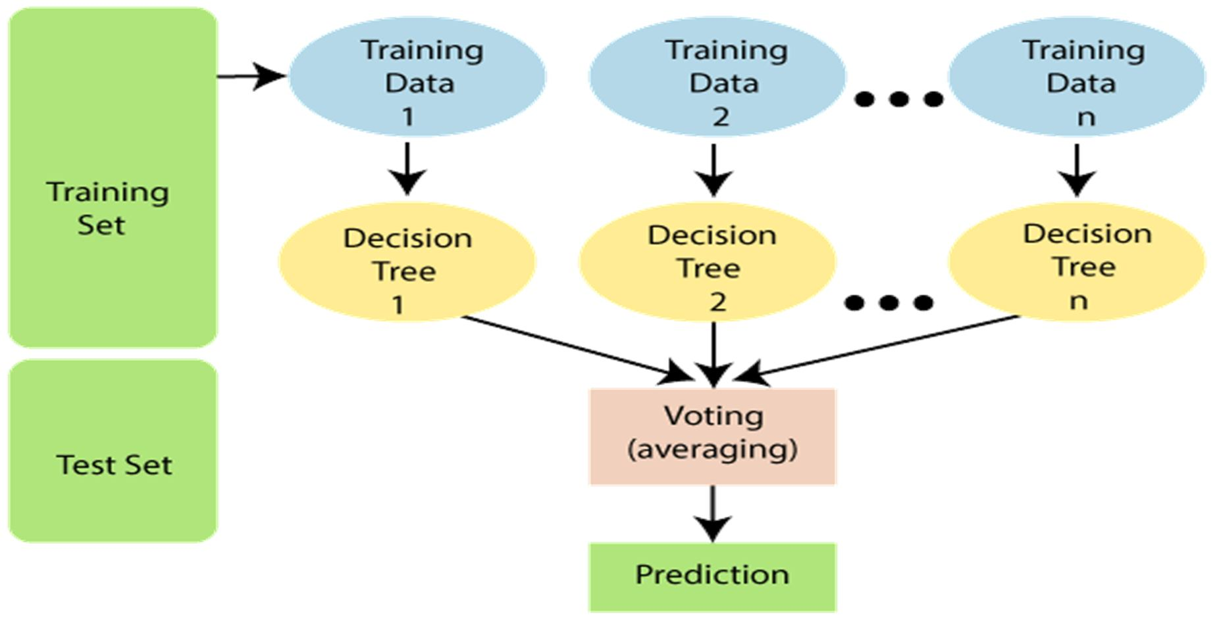

Fig: 2 Working of the Random Forest algorithm

2) The KNN Algorithm: In the K-NN algorithm, a data point is selected for which there is no known categorization, and the number of neighbours, k, is then determined. The following step is to choose k neighbours based on the lowest Euclidian distance between the chosen data points and their neighbours. After that, the chosen data point is put into a category that corresponds to the category with the largest number of neighbours among the K neighbours.
3) Support Vector Classifier: The SVC model reflects the many stages of the hyperplane in multidimensional space. To reduce mistakes, the SVC renders the hyperplane. We classify the dataset in SVC to create a high-density hyperplane (MMH).
4) Decision Tree Algorithm: A partitioning algorithm that operates on class and numeric data is the Decision Tree algorithm. It creates tree structures and is very easy to use and analyze data in tree graphs.

Result And Analysis
To determine the most precise forecast of a patient's risk of heart disease, this research article will evaluate the efficacy of various machine learning algorithms. The UCI database was used to conduct this investigation utilizing the Random Forest, Decision Tree, Support Vector Machine, and K-Nearest Neighbor methods. Python was used to train the models, identify accuracy points, and divide the data set into training and test data. This is a comparison of the algorithms' results, along with a table listing their accuracy percentages.

Algorithm | Accuracy
K-Nearest Neighbor
Support Vector Classifier
Decision Tree Classifier
Random Forest

Table: 3
Future scope
There are several potential areas for future development in heart stroke prediction, including the use of artificial intelligence and machine learning to improve prediction accuracy, personalized medicine that takes into account an individual's unique genetic makeup, remote monitoring technologies to provide early intervention for high-risk patients, improved risk assessment tools such as imaging techniques and blood tests, and increasing public education and awareness about heart stroke risk factors and symptoms to reduce incidence and improve outcomes.

Conclusion
The main goal is to outline the numerous ML methods that can be used to foretell cardiac disease. With a limited set of features and an appraisal of the study's objectives, effective and reliable forecasts can be made. The model utilises the previously processed data. The methods K-Nearest Neighbor (%), Random Forest (%), and Support Vector Classifier (%) all perform admirably. The Decision Tree Classifier, however, only offers a % accuracy rate. This research that incorporates time series, integration rules, and integration with other integration methodologies can yet be expanded. Given the constraints of this study, complicated models and model combinations are required to accurately predict early cardiac disease. The suggested system is GUI-based, approachable, scalable, trustworthy, and extendable. By offering early diagnosis, the proposed operating paradigm can also aid in lowering treatment costs. In addition to being a soft diagnostic tool for doctors and cardiologists, the model can also be used as a training tool for medical students. This tool can be used by general practitioners to make the initial diagnosis of cardiac patients. The scalability and accuracy of this prediction system can both be improved in a number of different ways. We have created a generalized framework that we may now utilise to analyse various data sets in the future.
References
- Seckeler MD, Hoke TR. The worldwide epidemiology of acute rheumatic fever and rheumatic heart disease. Clin Epidemiol. 2011;3:67.
- Weng SF, Reps J, Kai J, Garibaldi JM, Qureshi N. Can machine learning improve cardiovascular risk prediction using routine clinical data? PLoS ONE. 2017;12(4):e0174944.
- Mohan, S., Thirumalai, C., & Srivastava, G. (2019). Effective heart disease prediction using hybrid machine learning techniques. IEEE Access, 7, 81542- 81554.

